**GITLAB POC**

**For running Gitlab pipeline we need to do some configurations on AWS**

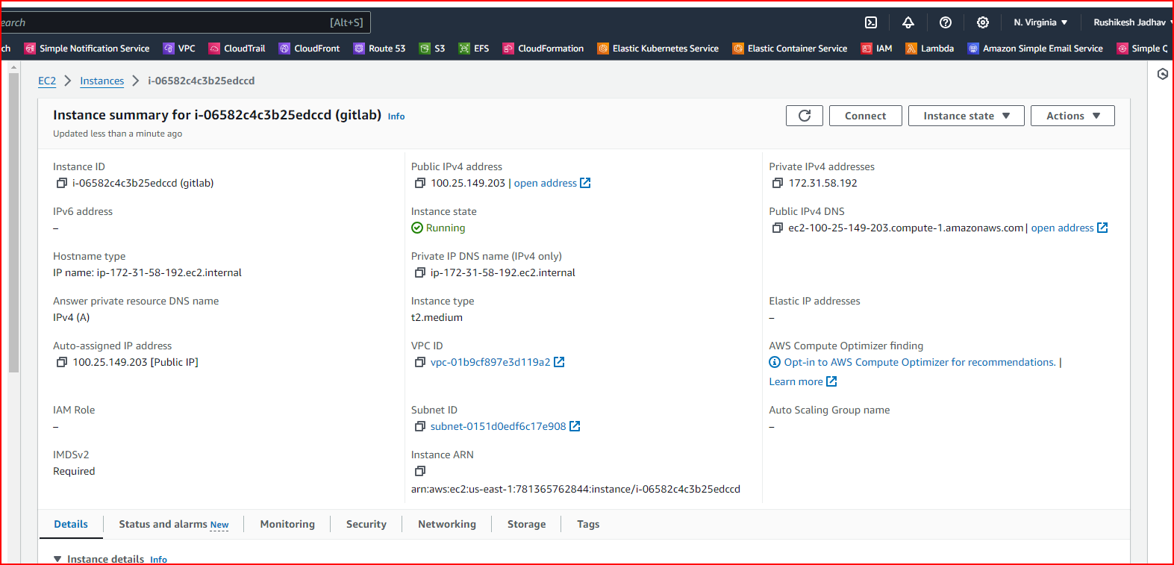

**Security group**



**ECR**

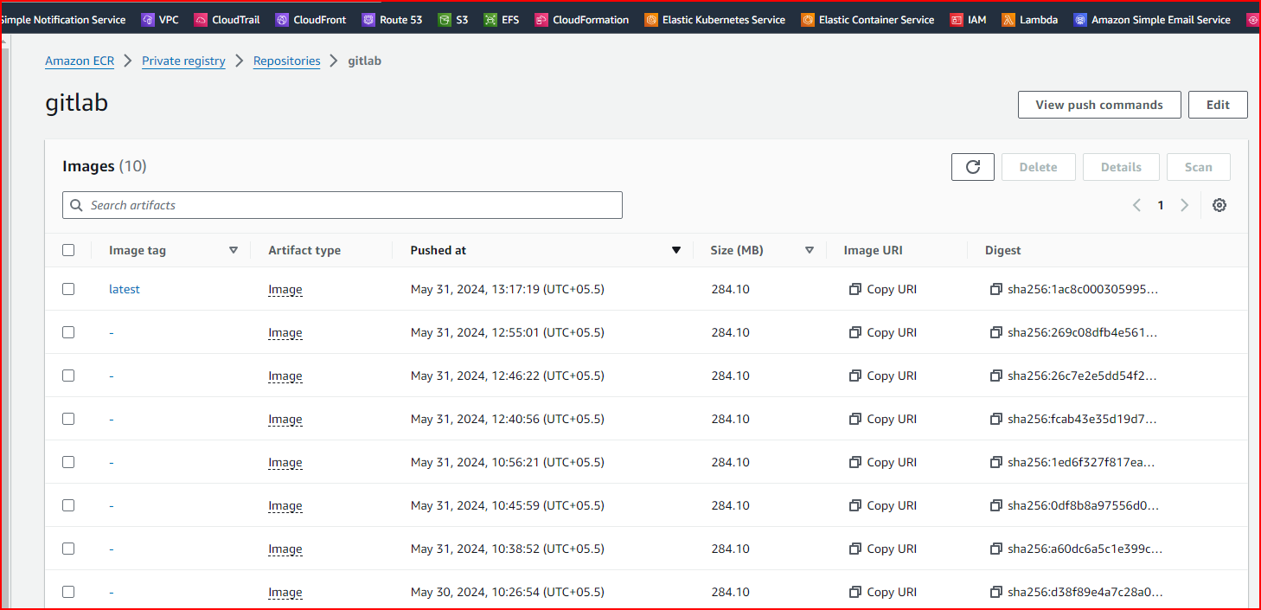

**IAM**

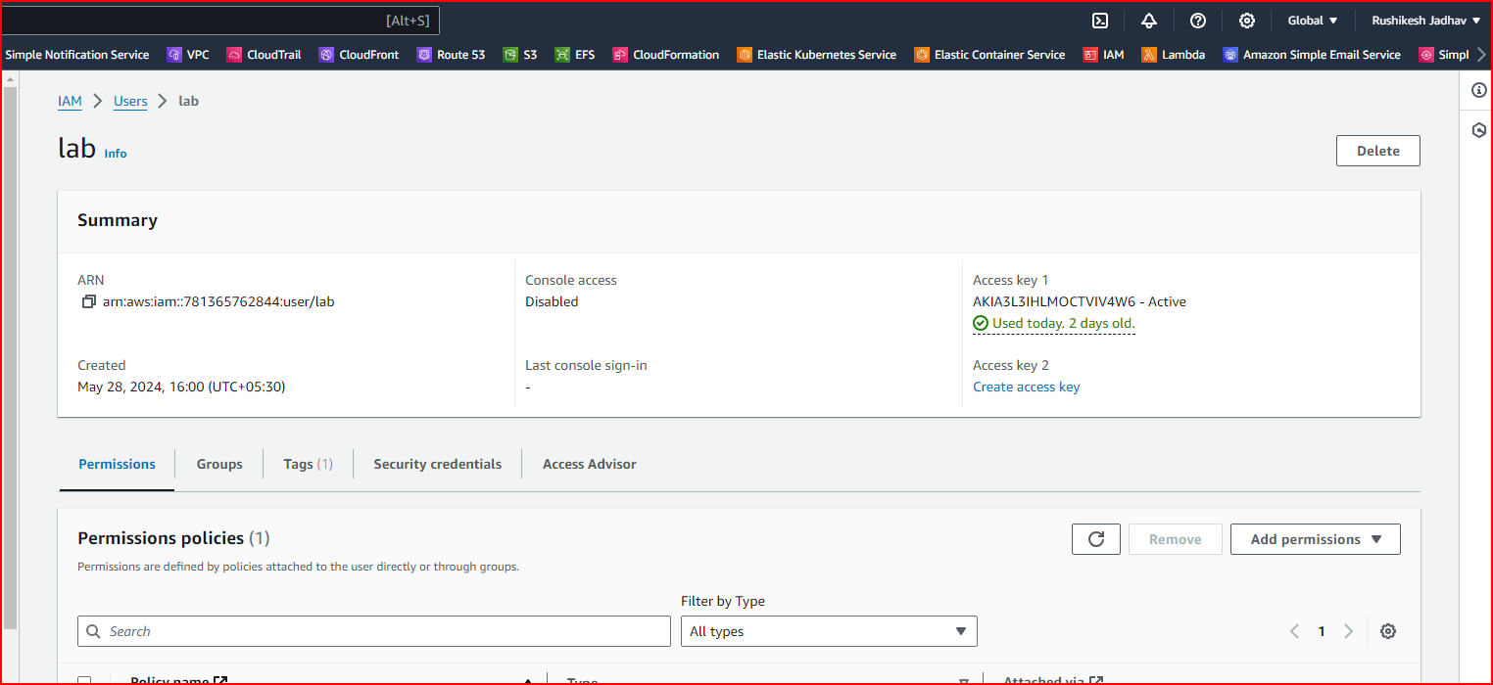

**Import project from GITHUB**

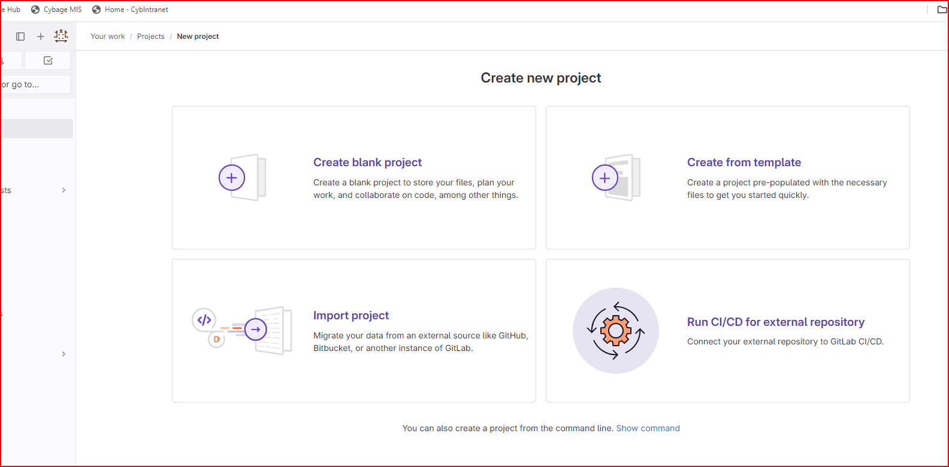

**After that go to project tab on left side and select your project**

**Create .gitlab-ci.yml file inside the project and start writing yml file.**

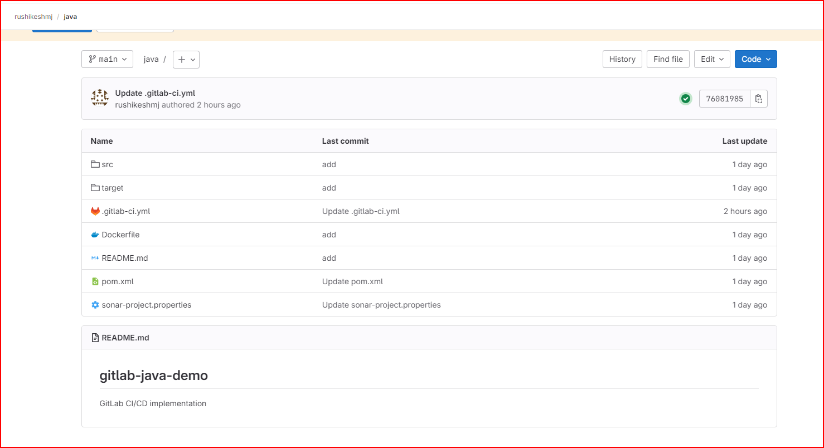

**After doing this install some application on EC2 Console**

sudo apt-get update

sudo apt-get install docker.io

sudo su

sudo curl -L --output /usr/local/bin/gitlab-runner https://gitlab-runner-downloads.s3.amazonaws.com/latest/binaries/gitlab-runner-linux-amd64

sudo chmod +x /usr/local/bin/gitlab-runner

sudo chmod +x /usr/local/bin/gitlab-runner

sudo useradd --comment 'GitLab Runner' --create-home gitlab-runner --shell /bin/bash

sudo gitlab-runner install --user=gitlab-runner --working-directory=/home/gitlab-runner

sudo gitlab-runner start

sudo gitlab-runner register

sudo vi /etc/gitlab-runner/config.toml

sudo gitlab-runner restart

docker run -d --name sonarcontainer -p 9000:9000 sonarqube

docker ps

docker run -d --name jenkinscontainer -p 8080:8080 jenkins/jenkins

docker ps

sudo apt-get install -y curl unzip

curl "https://awscli.amazonaws.com/awscli-exe-linux-x86_64.zip" -o "awscliv2.zip"

unzip awscliv2.zip

sudo ./aws/install

aws --version

aws configure

aws login

**1.  CI steps for GitLab workflow which includes ( Use Self Hosted Runner )**

1. **Checkout code to repo**
2. **Unit testing**

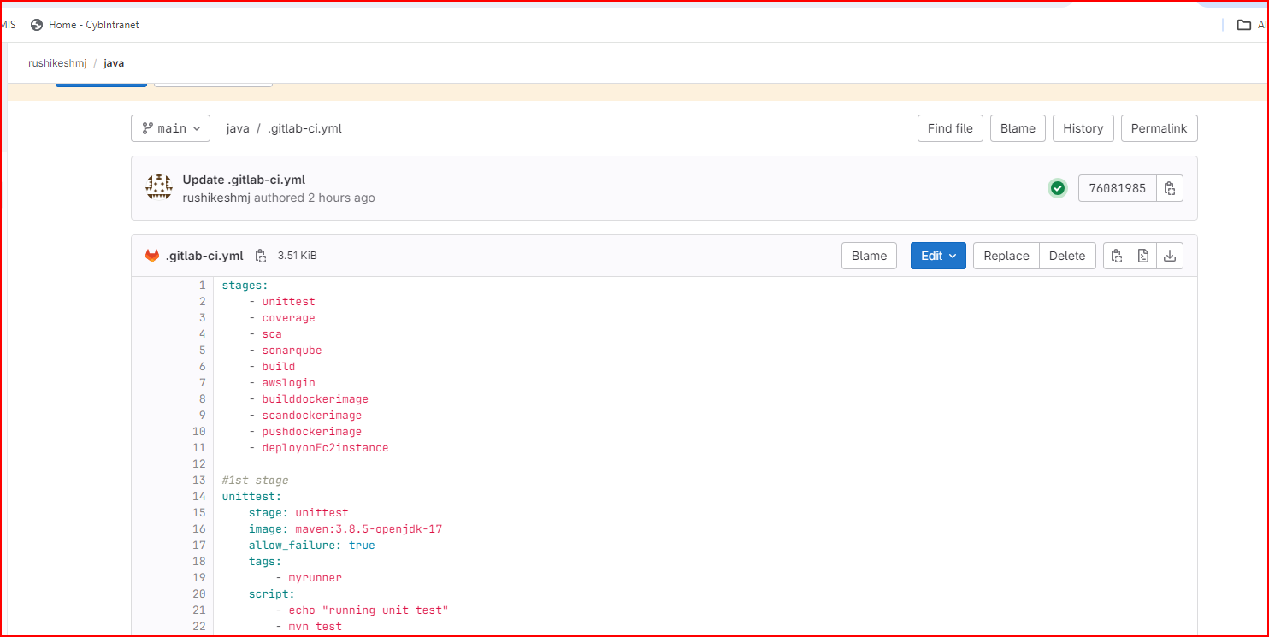

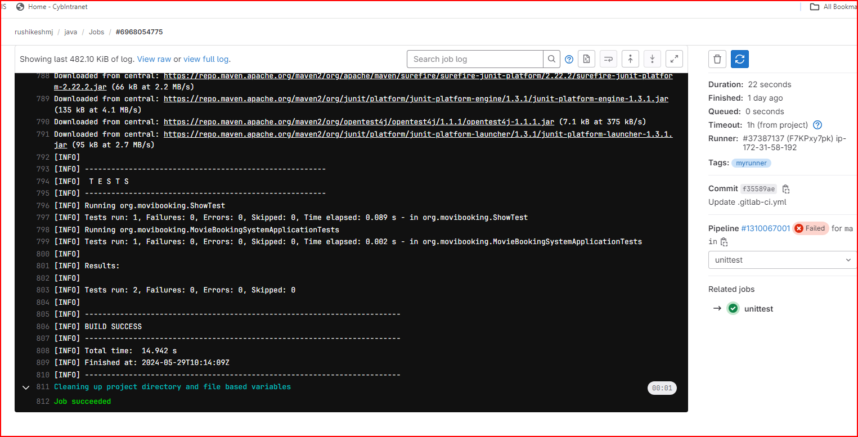

1. **code coverage using jacoco**

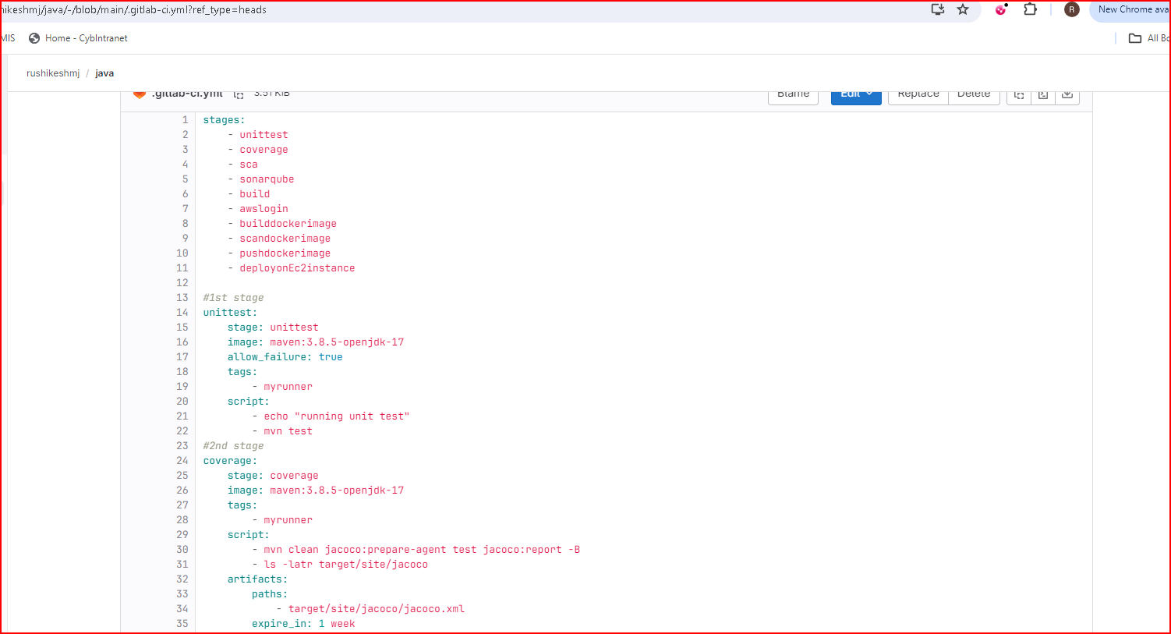

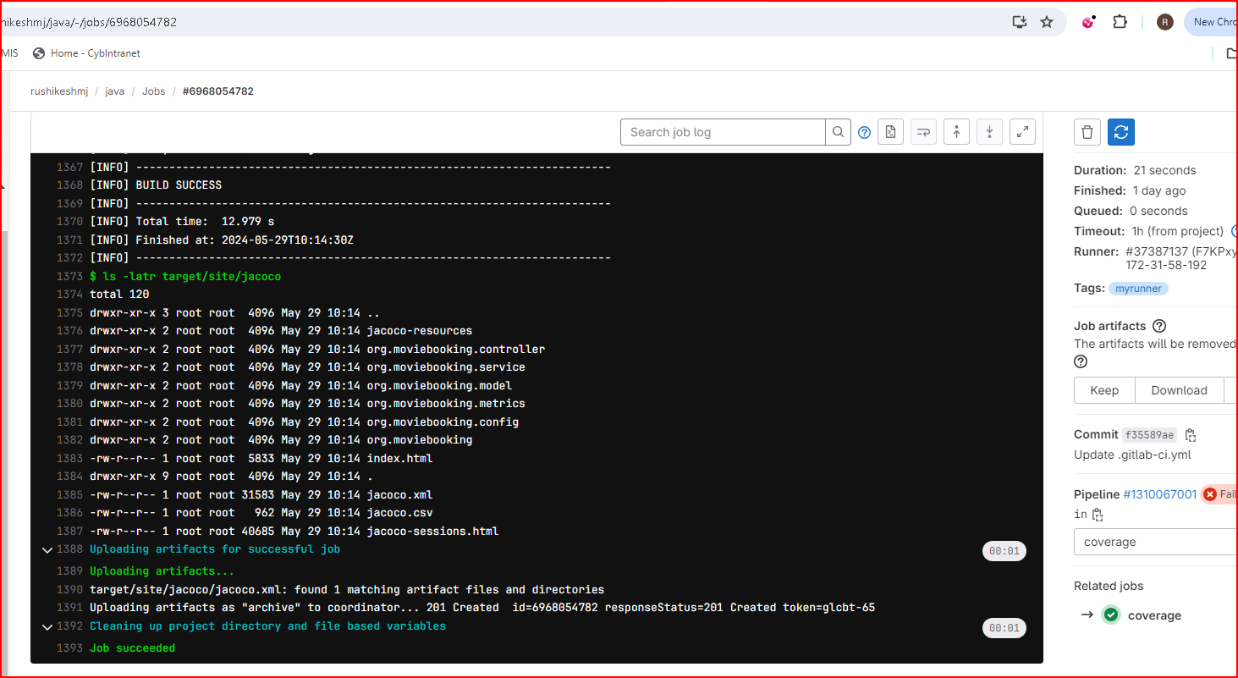

1. **SCA using SonarQubes along with quality gates**

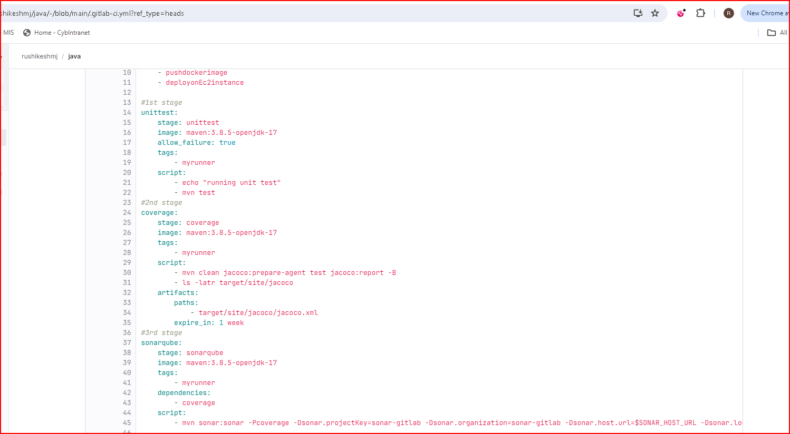

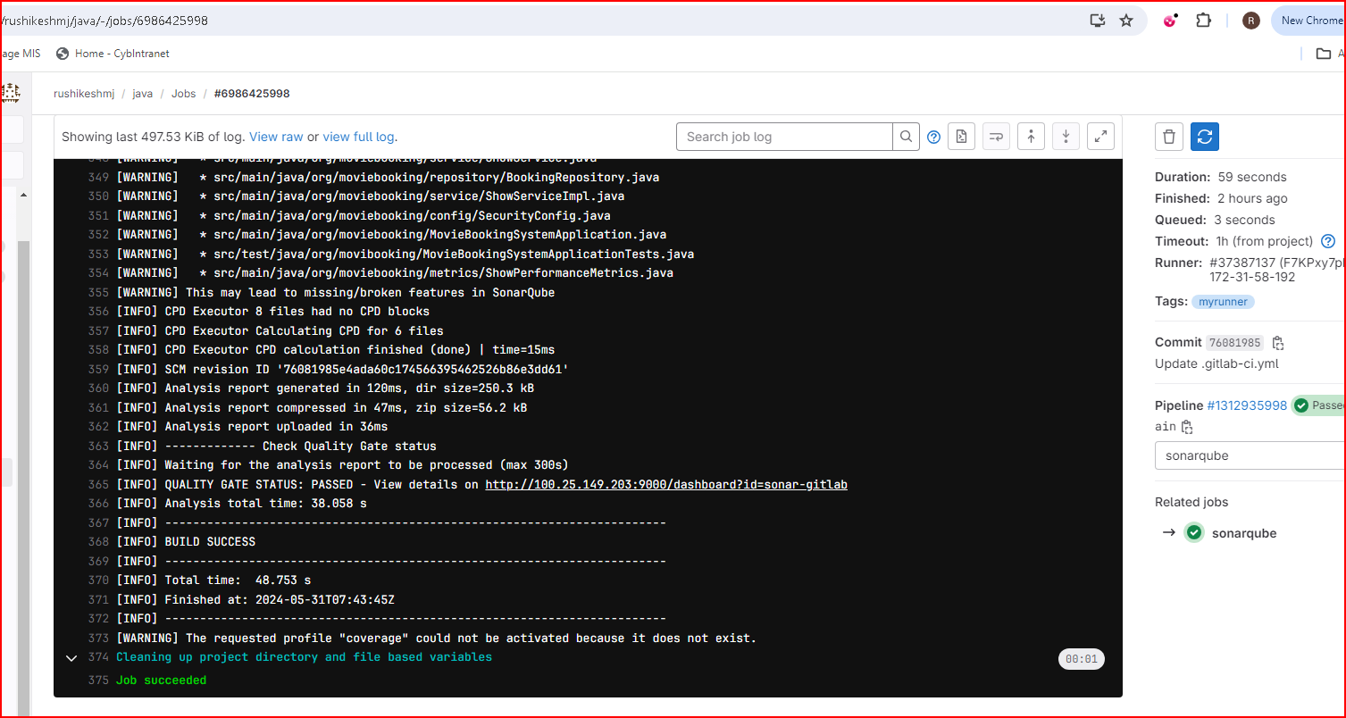

1. **Build and package JAR**

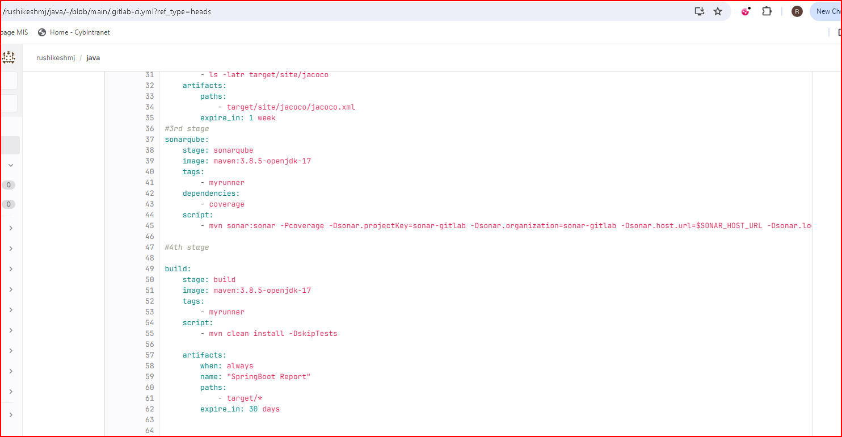

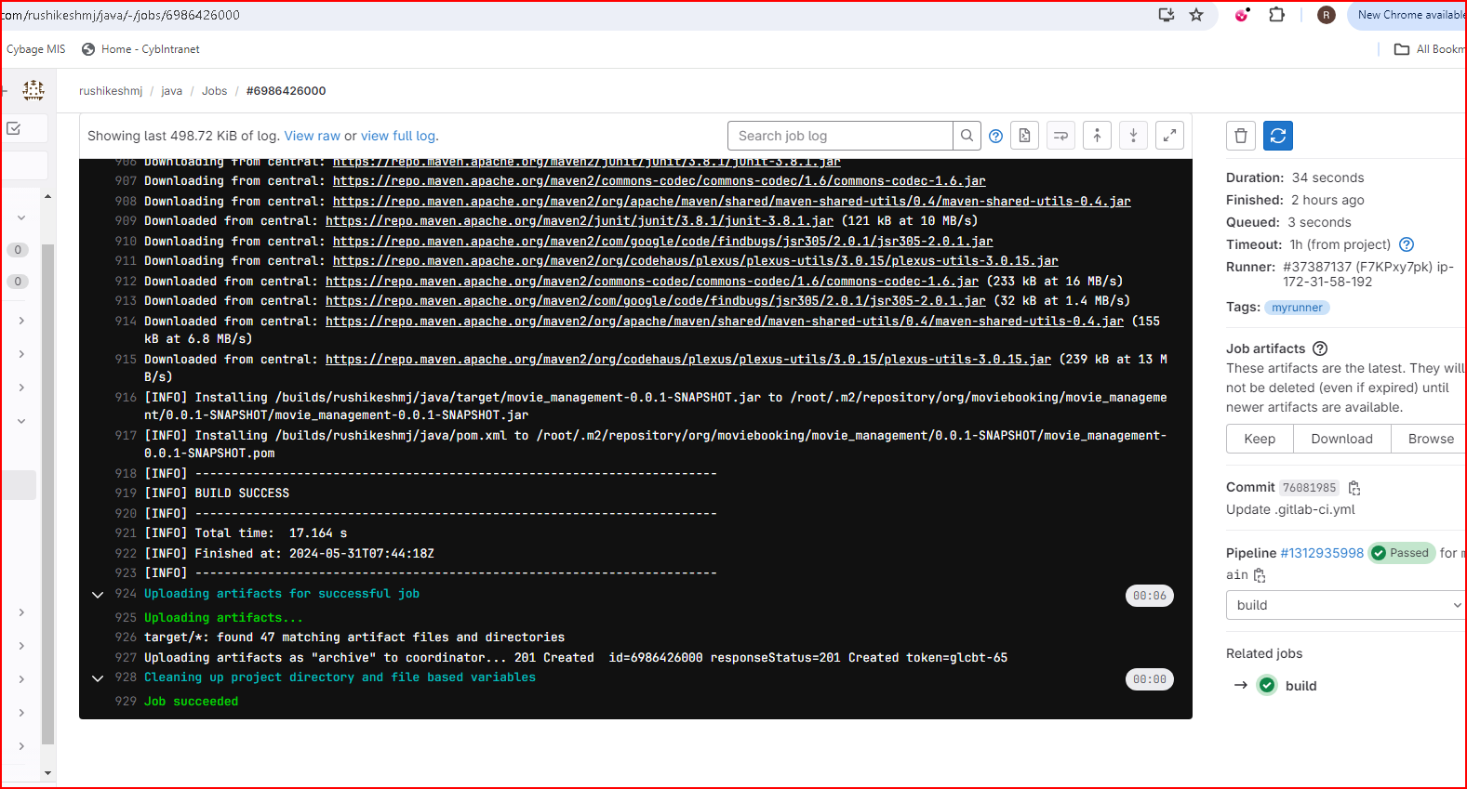

1. **Configuration of AWS**

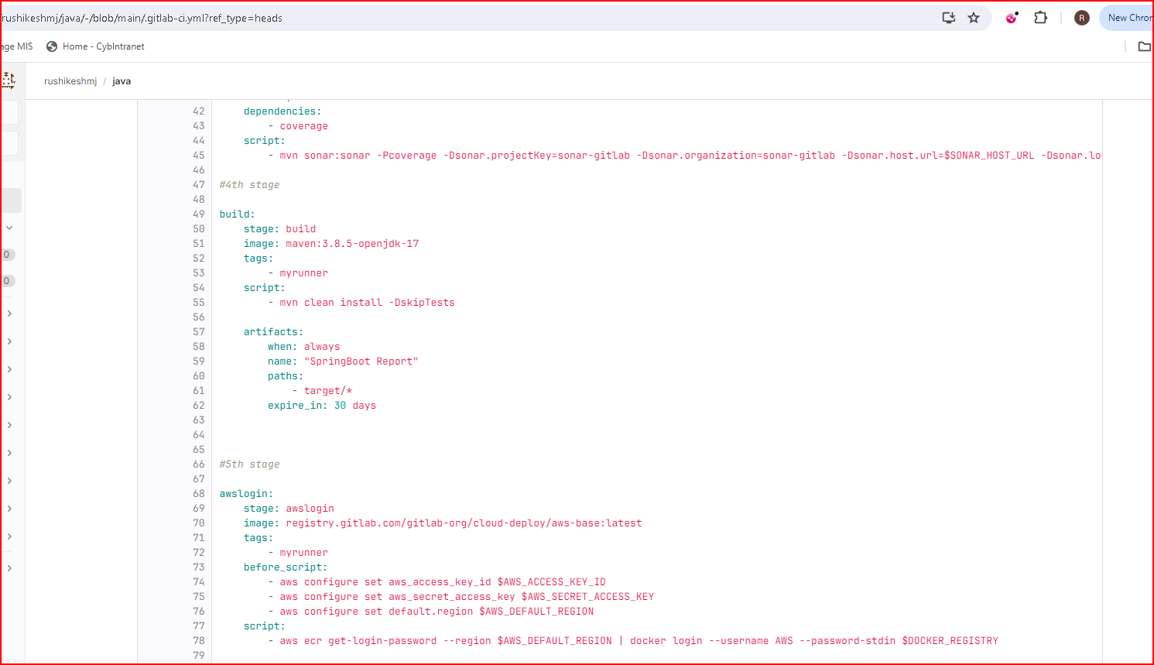

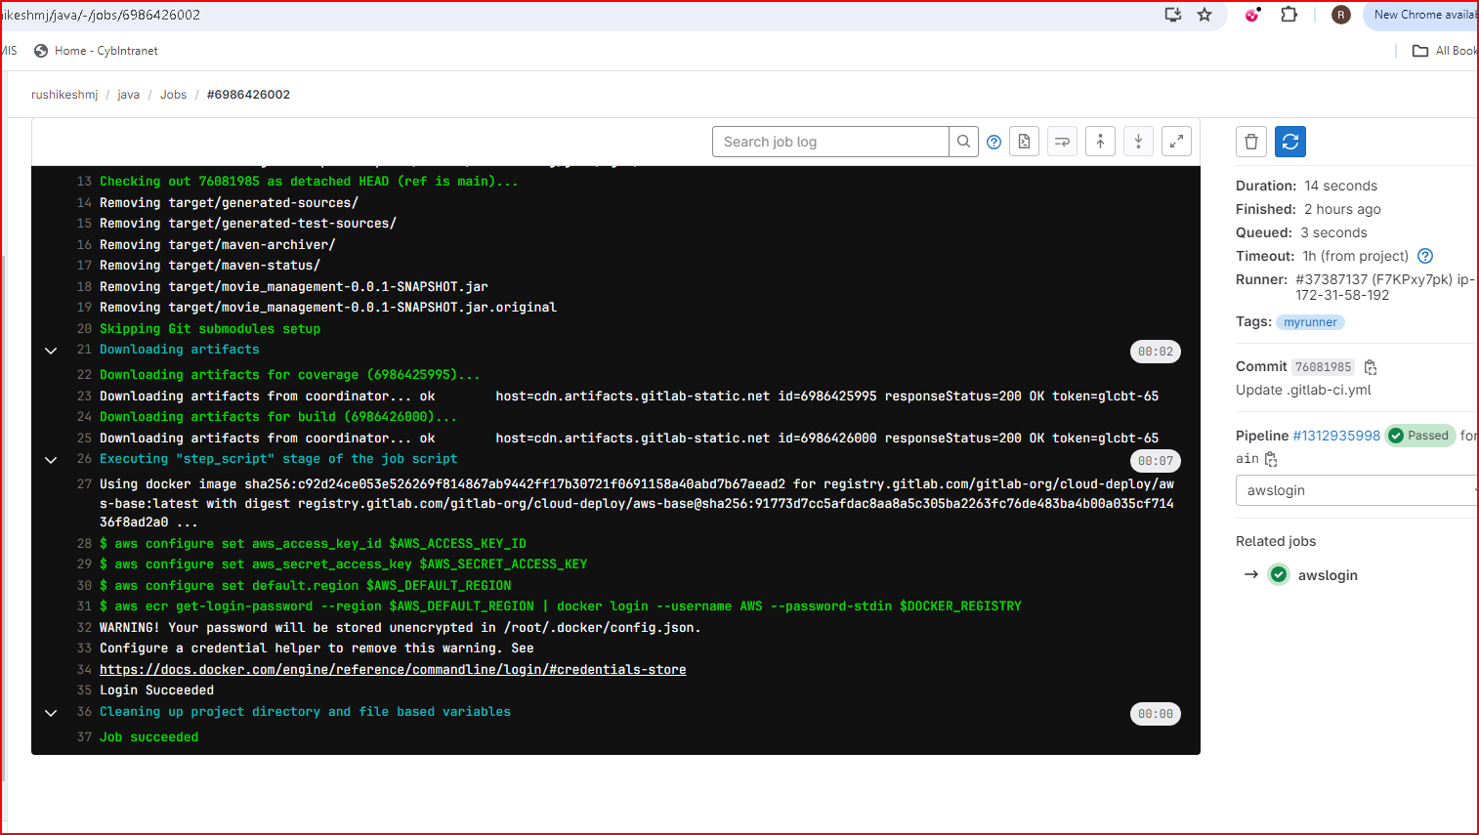

1. **builddockerimage**

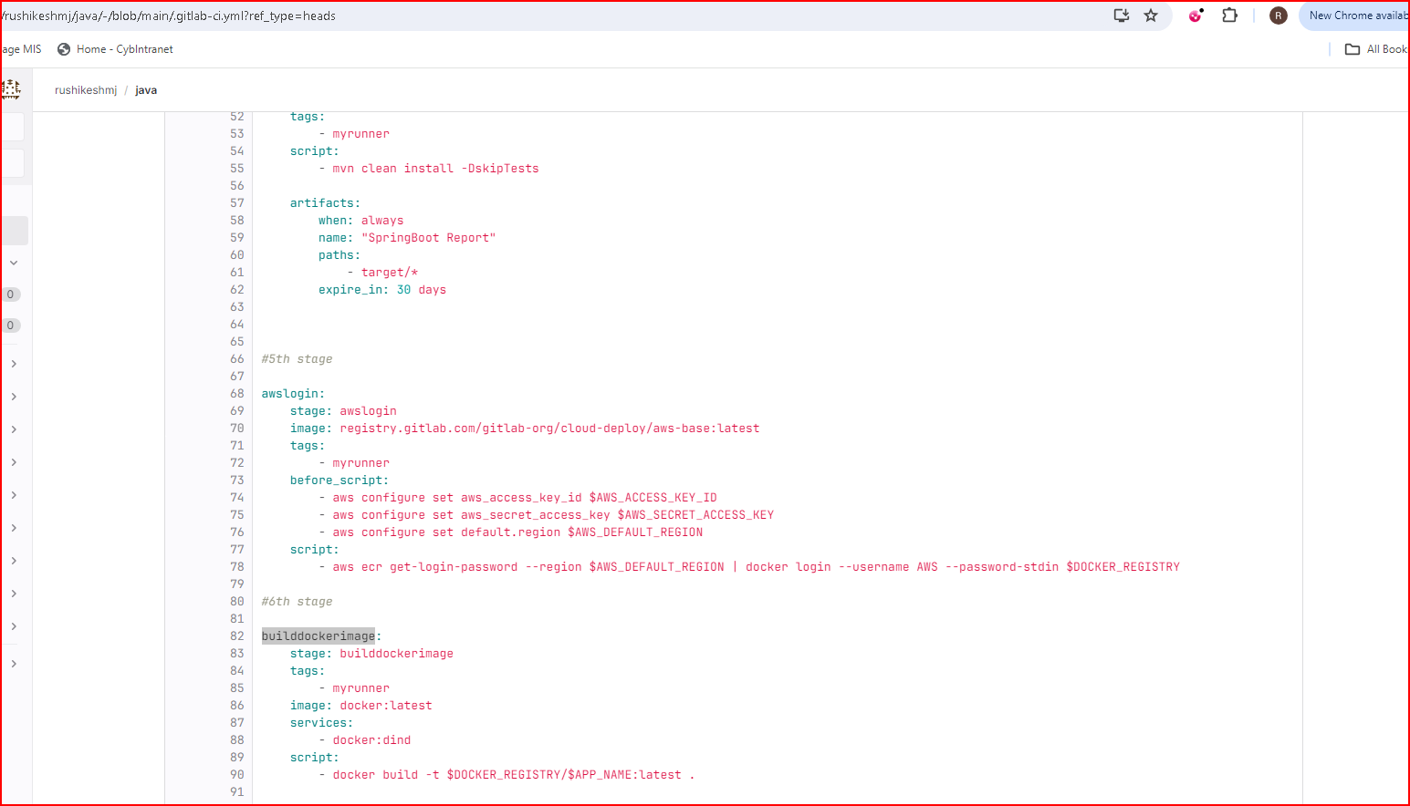



1. **scandockerimage**

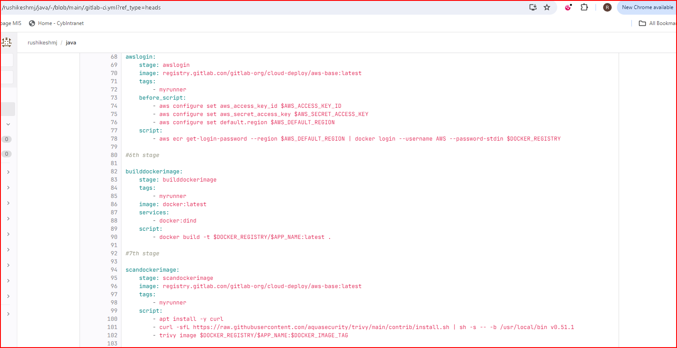

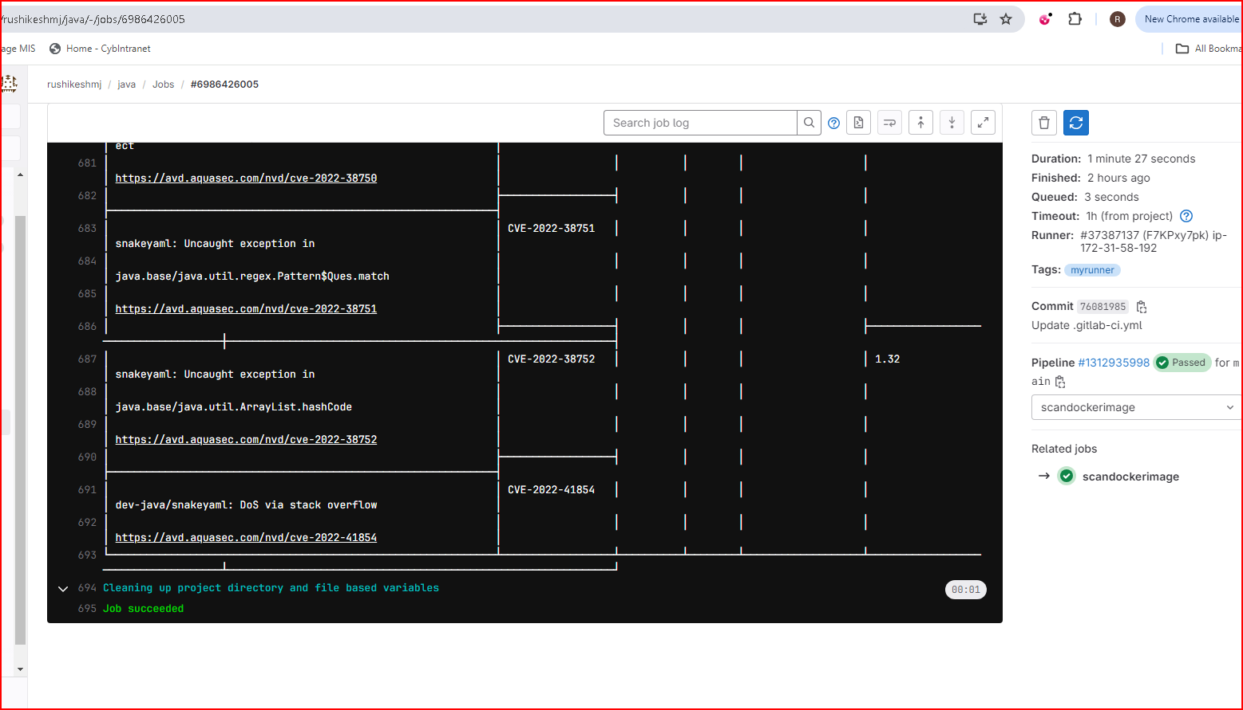

1. **pushdockerimage**

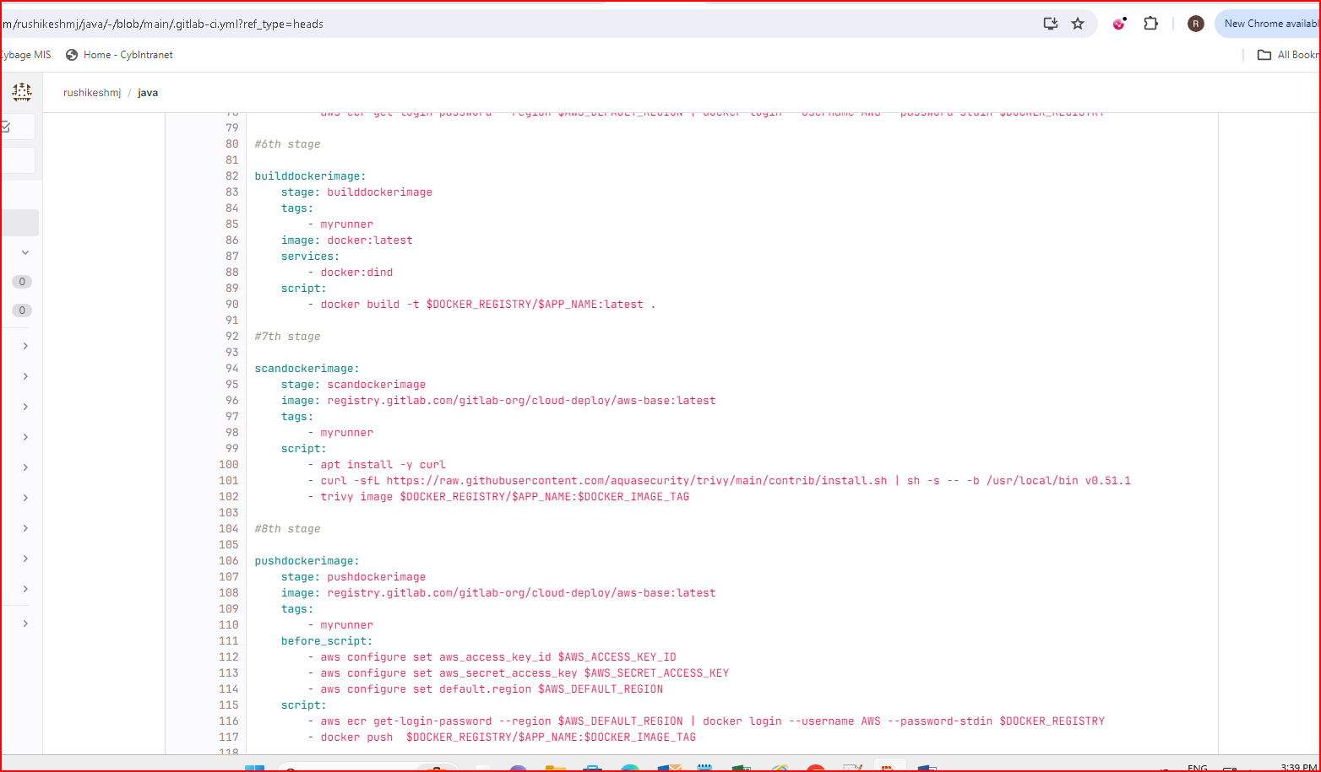

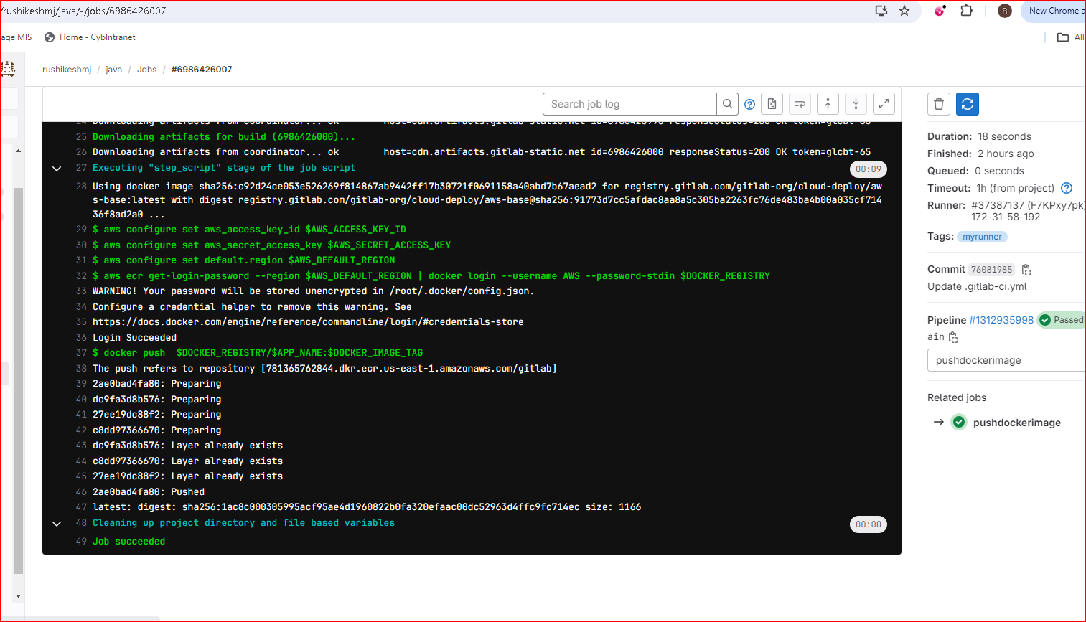

**2. CD steps includes**

**1.  Deploy application on EC2 using SSH Private Key**

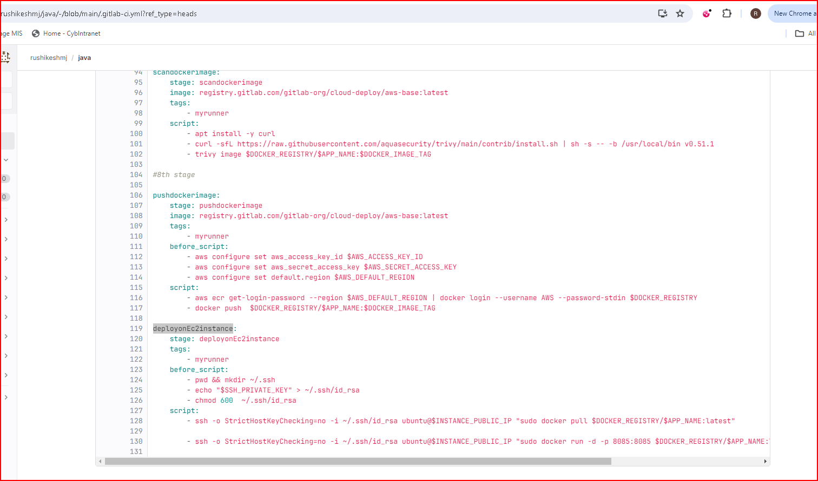

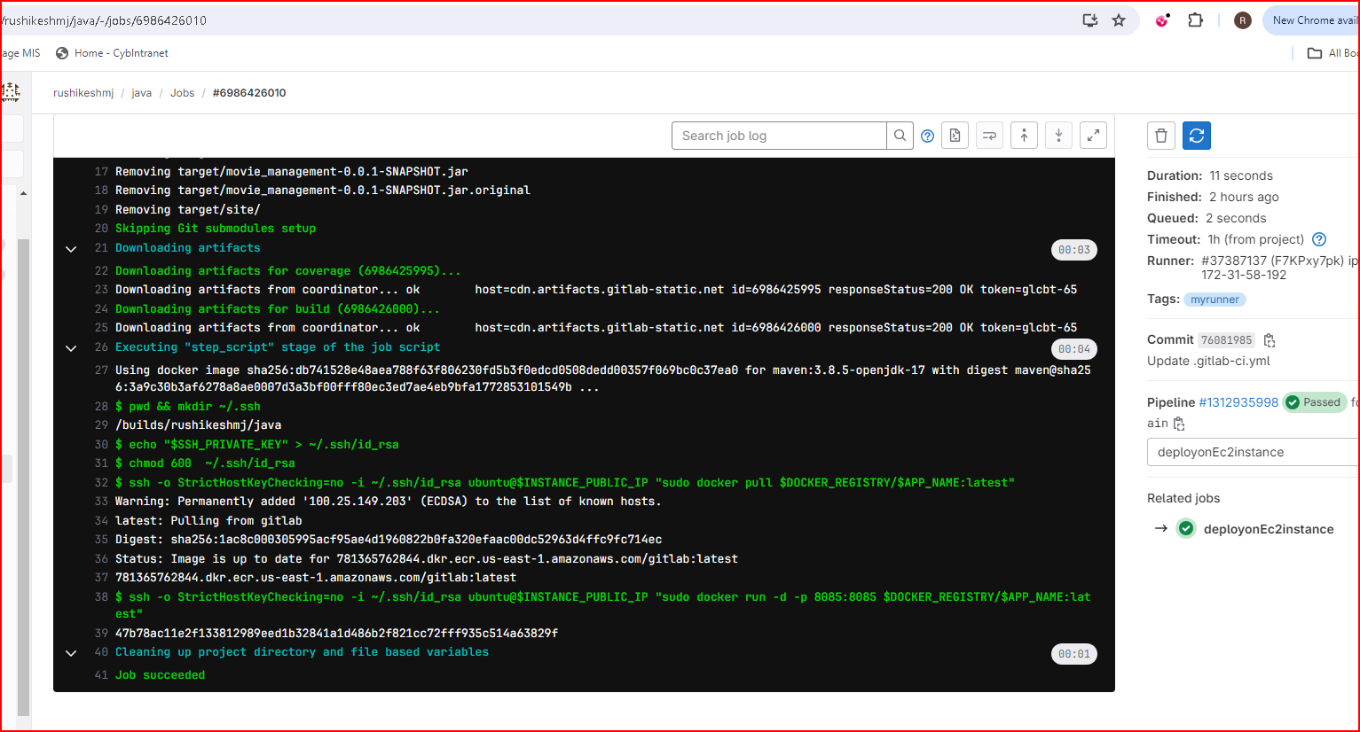

**Complete pipeline**

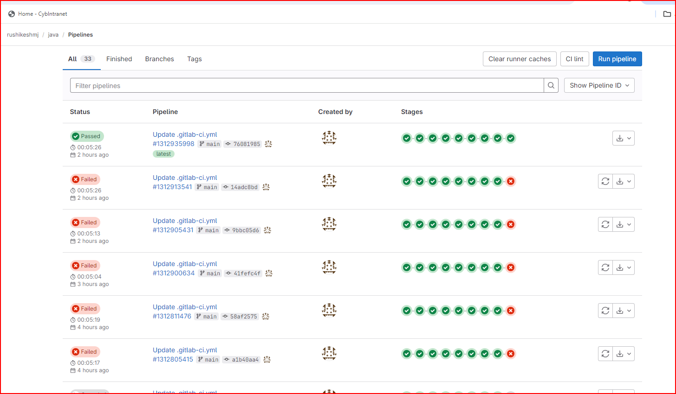

**For above pipeline code we need to set variables in settings--CI/CD-- variables**

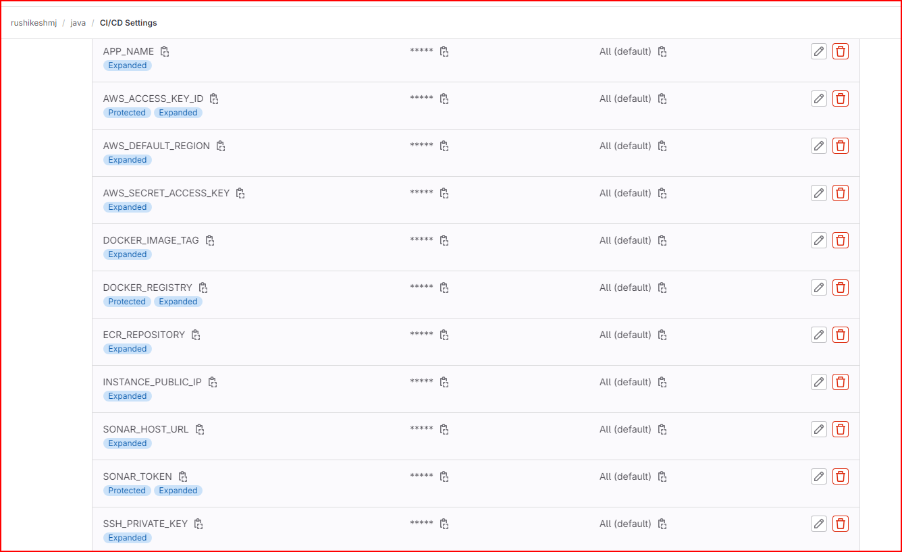

**3. Integration of tools**

**Jenkins GitLab Integration using same GitLab Repo**

**Create Job**

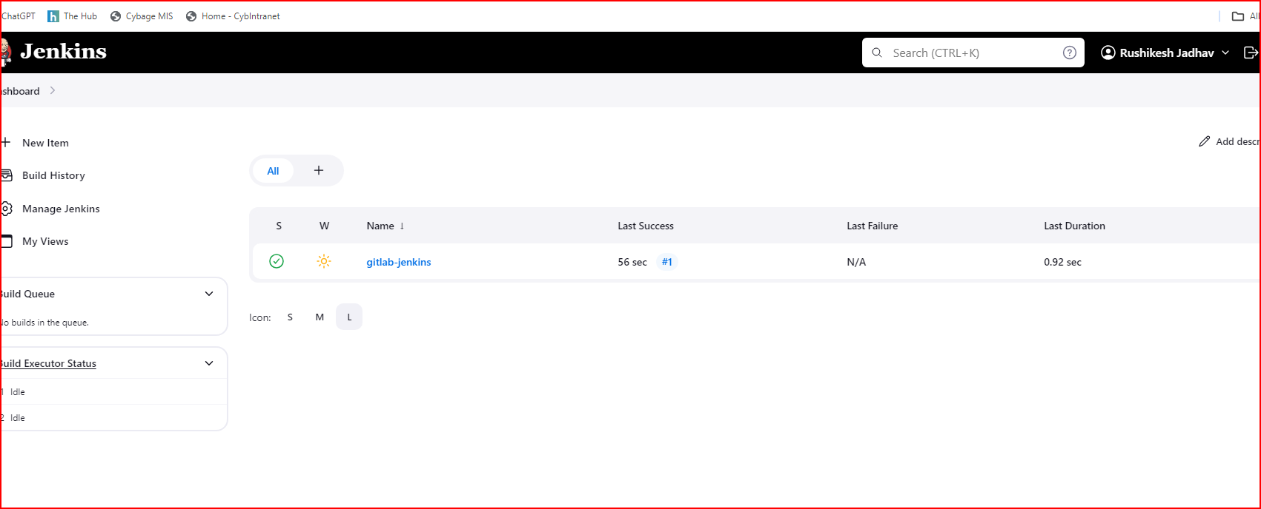

**Download plugins of gitlab**

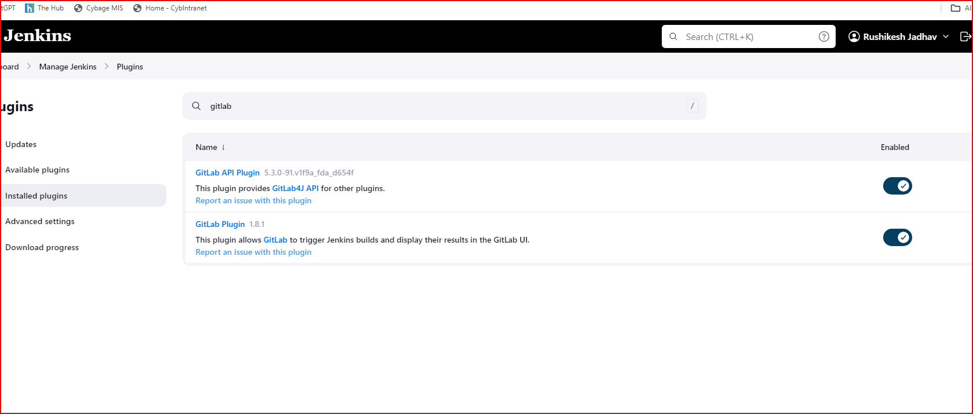

**Add Gitlab credentials**

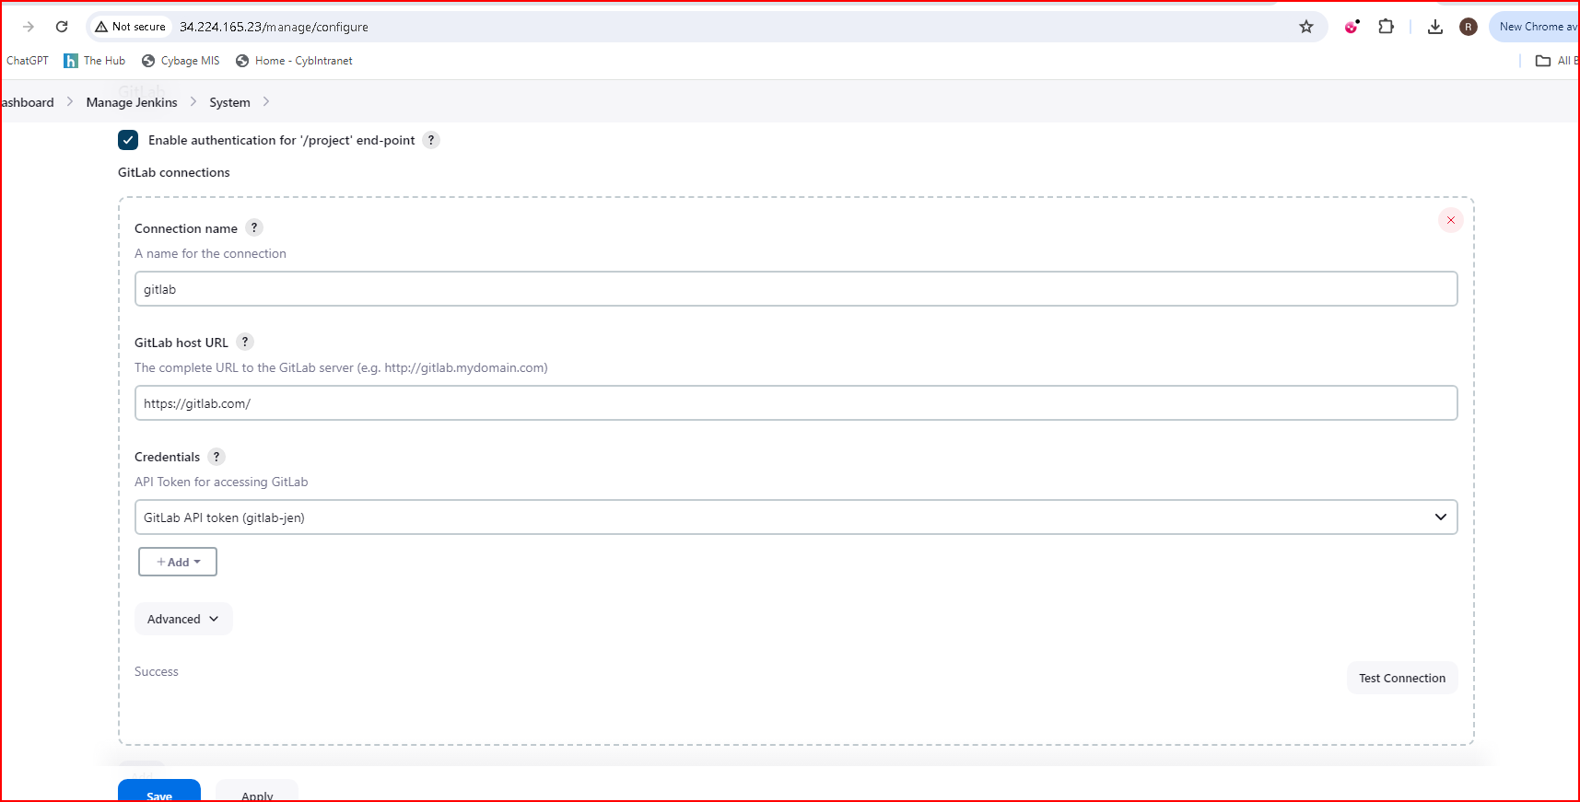

**We can see added credentials here**

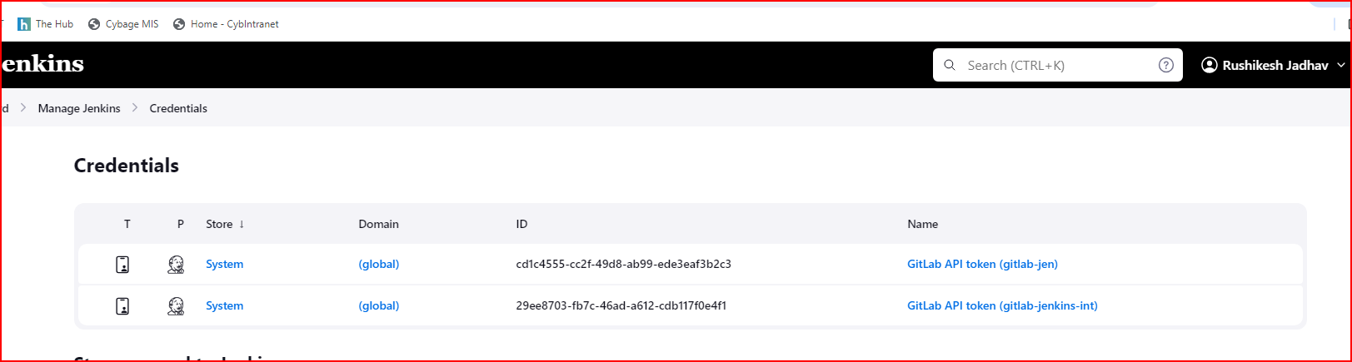

**API Token from Jenkins to access webhook**

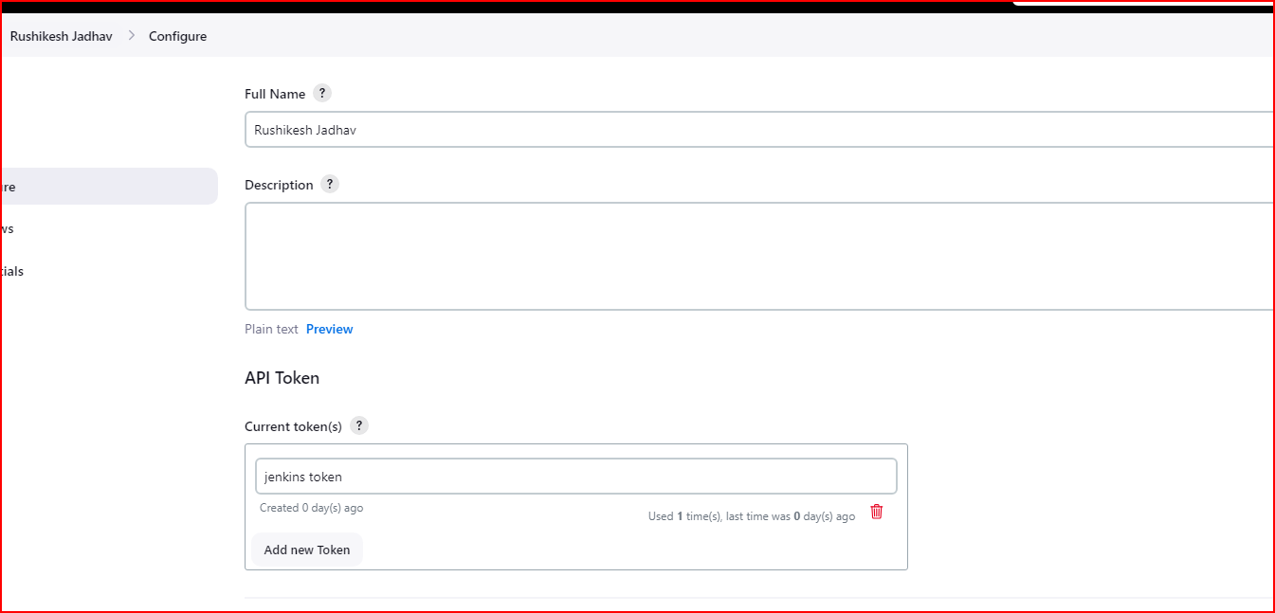

**GitLab events trigger webhooks**

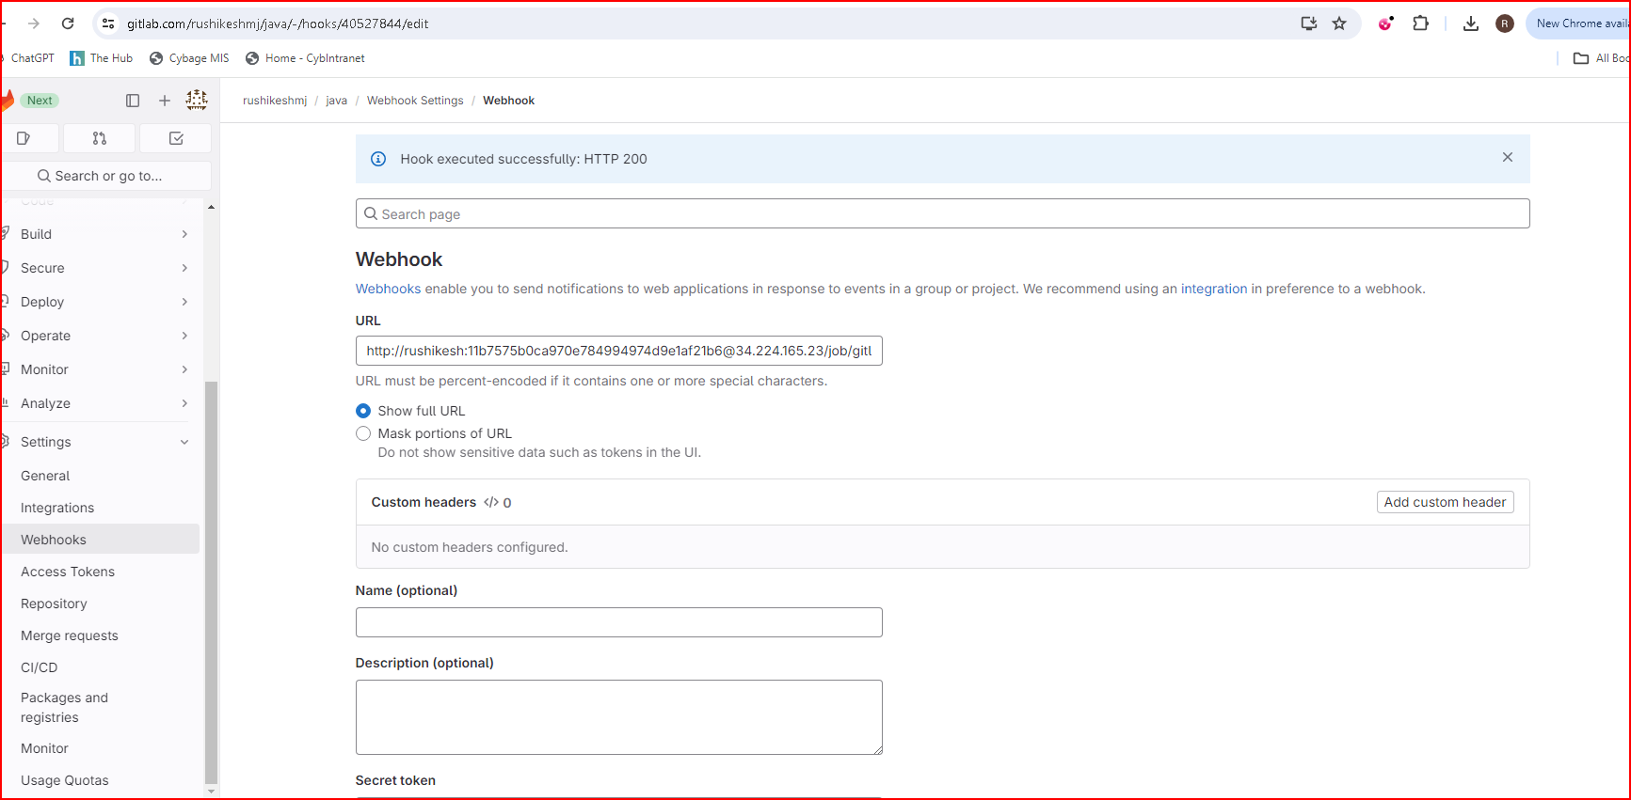

**Console output**

